TEXAS ALP FALL CONFERENCE
“El Paso—Celebrating the Spirit of Texas for 441 Years”
Virtual ♦ October 14-15, 2022
Registration Deadline—October 1, 2022
REGISTRATION FORM  Name  Address  City/ST/ZIP  Daytime Phone  E-mail  (Check all that apply)  Certifications:  ALP PLS/CLP PP SC ___________________________  CLA/CP ACP RP TSC __________________________  Other  NALS Life Member  Texas ALP Past President  This is my first Texas ALP meeting  I want to be a Texas ALP PAL  Local Chapter  Current Local Position Held  Current Texas ALP Position Held  Current NALS Position Held | FULL REGISTRATION FEES  ***Note: Regular and Late Registrations include all events***    Board Meeting Only (Friday)……………………………….……N/C    NALS Member $75    Texas ALP Chair $ 25    Nonmember $125    Student $ 75  Late Fee (postmarked after October 1, 2022) $ 25  Designated Charity is  The Rescue Mission of El Paso  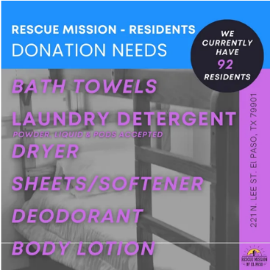  https://rmelp.org/volunteer-%2B-donate-1
SCHEDULE OF EVENTS  (Please indicate each event you will attend)  Friday, October 14, 2022  3:00 pm – 4:00 pm Professional Development  4:15 pm – 5:00 pm Open Forum  5:30 pm – 6:30 pm Board Meeting  Saturday, October 15, 2022  9:00 am–10:00 am – Charles Kramer, Hunter & Kramer, P.C.  Tips and Traps of Transactional Real Estate Practice  10:00 am–10:15 am - Break  10:15 am–11:30 am – Cori Harbour-Valdez, The Harbour Law Firm, P.C.  4th Amendment Refresher: Illegal Search & Seizure  11:30 am–12:00 pm - lunch break  12:00 pm–1:15 pm – Stephen Venzor, ScottHulse, P.C.  EEOC Investigations  1:30 pm–2:30 pm - Cindy Izquierdo, Farmer’s Insurance Exchange  Examples of Social Media Admissibility  2:30 pm–2:45 pm - Break  2:45 pm–3:45 pm - Carlos Garcia-Aguilar, Attorney at Law  Web3 Legal Discussion | PAYMENT INFORMATION  Total Amount Due: $__________ (due with registration form)  Please make check payable to:  El Paso Association of Legal Professionals Special Meeting Account  Federal Tax ID No. 23-7024631  Notice: A $30 fee will be assessed for returned checks. Refunds requested and confirmed in writing (less a $25 fee) will be made until October 1, 2022.  Mail registration form to:  Faynell Poe, PP, PLS  P. O. Box 942  El Paso, Texas 79946-0942  For questions about registration, contact Registration Chair:  Faynell Poe, PP, PLS  915-532-7500 or fpoe@fbknlaw.com
Contributions or gifts to Texas ALP are not deductible as charitable contributions for income tax purposes.

